FRUITS
A fruit is a fully grown fertilized ovary containing one or more seeds. A fruit has 2 scars, one where it was attached to the receptacle and the other, the remains of the style or stigma.
During a fruit formation, the wall of the ovary becomes a fruit wall called pericarp. In some fruits such as banana and pine apple, the fruits develop without fertilization. Such fruit are said to be parthenocarpic fruits. Therefore parthenocarpy is the development of fruits without fertilization.
Classes of fruits
True fruits: develop only from the ovaries of a flower e.g. beans, tomatoes, etc.
False fruits: develop from the association of ovaries and other floral parts such as receptacle. Examples include; pineapples and apples.
Classification of fruits
There are 3 groups of fruits namely;
- Simple fruits
- Aggregate fruits
- Multiple fruits
Simple fruits
These are formed from one flower in which the pistil consists of either one carpel (monocarpic) or of several fused together (syncarpous) e.g. legumes, g, nuts, peas, tomatoes, mango, beans, etc.
Aggregate fruits
These are formed from one flower in which the pistil consists of several free carpels (apocarpous) e.g. apples and rose.
Multiple fruits
These are formed from several flowers and the ovaries become fused after fertilization e.g. jackfruit and pineapple.

SIMPLE FRUITS
There are either dry or succulent according to whether the pericarp becomes dry or juicy as the fruit ripens.
Types of simple fruits
Simple fruits are further divided into three categories.
- Dry indehiscent fruits 2. Dry dehiscent fruits 3. Succulent fruits.
Dry indehiscent fruits
These are fruits with a dry pericarp that does not split up (dehisce) to release seeds. This category contains five types of fruits. These are Achene, Nut, Caryopsis, Cypsela and Samara.

The table below shows the different types of dry indehiscent fruits.
Type of dry indehiscent fruit | Description | Illustrative diagram
Achene | This is a one seeded fruit covered by a dry pericarp, which does not split open, e.g. sunflower. The achene is the simplest fruit. | An achene of sunflower.  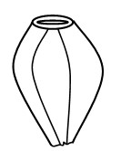
Nut. | This is similar to an achene but the pericarp is hard and tough, e.g. cashew nut.  Note; coconuts and groundnuts are biologically not nuts. | Section through a cashew nut  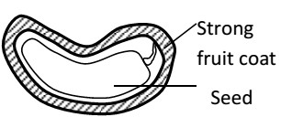
Caryopsis. | This is an achene-like fruit in which the testa and pericarp are fused. These are mainly found in grasses and maize. | Caryopsis of maize.  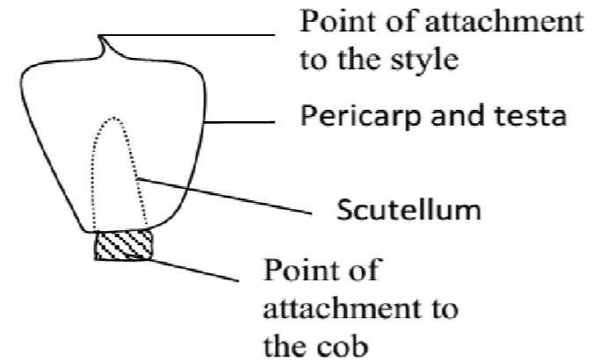
Cypsela | This is a fruit similar to an achene in which the inferior ovary has a pappus of persistent calyx. It is common in composite fruits, e.g. tridax and bidens pilosa | Cypsela of tridax.  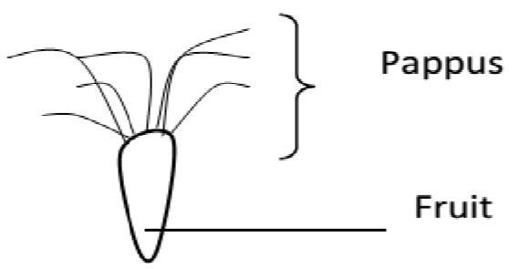
Samara. | This is a fruit similar to an achene in which the pericarp is extended to form one or more wings, e.g. in jacaranda and African rose wood. | Samara of jacaranda.  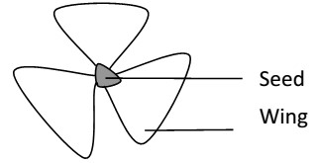

Dry dehiscent fruits
These are fruits with a dry pericarp that splits (dehisces) to release seeds. The fruits split at particular lines of weakness known as sutures. These fruits are categorized into the following different groups depending on the number of splits that occur on the pericarp. These fruits include, Follicles, Legume, Capsule and Schizocarp.

The table below shows the different types of dry dehiscent fruits
Type of dehiscent fruit | Description | Illustrative diagram
Follicle | This is a dry fruit with many seeds and splits open along one suture, e.g. Sodom apple | 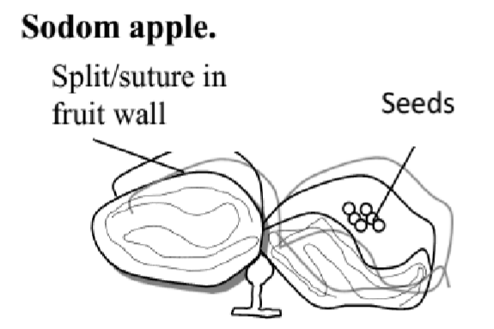
Legume. | This is a dry fruit with many seeds and splits open along two sutures, e.g. beans, peas, flamboyant and Barbados pride. | Legume of a bean  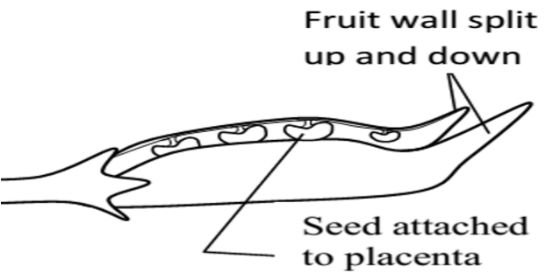
Capsule | This is a dry fruit with many seeds and splits open along many vertical slits. It is formed from an apocarpous flower, e.g. Dutchman’s pipe, balsam, cotton, e.t.c. | 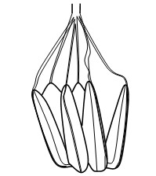
Schizocarp. | This is a dry several seeded fruit, which breaks up into  separate parts each containing one seed, e.g. desmodium, sweet hearts and some cassia. | 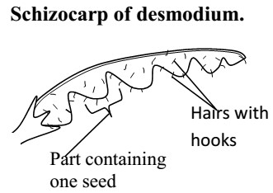

Succulent fruits
These are fleshy fruits. They are either entirely fleshy or have part of it fleshy.
They are further divided into 2 types.
- Drupes.
These are fruits with only one seed and only part of it fleshy (epicarp and mesocarp). The endocarp is fibrous and hard, e.g. mango and avocado.
Longitudinal section through a mango.

Fruit stalk (peduncle)

Epicarp

Mesocarp

Endoc
arp

Seed

- Berry.
This is a fruit with many seeds and the whole of it fleshy, e.g. tomatoes, guavas, oranges, bananas etc.
A berry of an orange (T.S).

Epicarp

Mesocarp

Endocarp

Seed

Placenta

Locule

Pericarp

Septum

- Pome
This is a succulent fruit in which the outer fleshy (normally edible) part develops from the calyx and receptacle. The ovary forms a papery aore containing seeds e.g. apple and pears.

PLACENTATION
This is the distribution of the placentae in the ovary or the arrangement of the seeds on the placenta within the ovary.
There are five types of placentation as shown in the table below.
Type of Placentation | Description | Example
Marginal | Ovules are situated at or near the margin of the ovary | Beans, peas, cassia
Axile | Ovules centrally located in the ovary with ovary divided into many chambers. | Orange and tomato
Central | Ovary is one chambered and ovules centrally located | Soap wort,
Parietal | Placenta is found on the inner wall of the fruit and the ovules are attached on the inner wall | Passion fruits pawpaw, cocoa
Free central | Ovules located on the projection from the base of a one chambered fruit | Green pepper
Basal | Ovule found on a placenta that arises from the base of the ovary, fruit usually single seeded | Mango, avocado.

FRUIT/SEED DISPERSAL
This is the scattering or spreading/displacement of fruits and seeds from their parent plants. In some plants, only seeds are dispersed while in others, fruits are dispersed with seeds.
Importance of dispersal
i) It helps to prevent overcrowding among plants of the same species. ii) It reduces competition between member plants of the same species. iii) It helps to minimize the spread of epidemic diseases especially in seedlings if they are crowded.
- It helps plants to colonize new areas which may even be better for the species survival.
- It enhances the chances of survival and continuity of the plant species.

Agents of dispersal
They include;
- Water,
- Wind
- Animals
- Self-dispersal/ explosive mechanism
Fruits and seeds possess specialized structure to aid their dispersal and are adopted to specific mode of dispersal.
Characteristics of fruits/seeds dispersed by wind
- They are usually small, light and dry which enables them to easily be carried or flown by wind.
- Some fruits like elm and tecoma have wing like structures that increase their surface area. This helps in delaying the fall of seeds and fruits and increases chances of being blown away.
- Some fruits like tridax and clancletion have parachute-like hairs called pappus which enables them to fleet and fly by wind.
- Some seeds like silk cotton possess thread-like structures called floss which increase surface area enabling the seeds to float in air.

Characteristics of fruits/seeds dispersed by water
i) They are usually light and contain air space inside which reduces their relative density and enable them float on water easily like the coconut. ii)
Characteristics of fruits/seeds dispersed by animals
- Some fruits such as tomatoes, oranges and mangoes are usually large and brightly coloured especially when ripe. This helps to attract animals.
- Some fruits when ripe are scented e.g. jack fruit. This helps to lure/attract animals.
- Some usually possess edible parts which are succulent / juicy and the only part of the fruit that is eaten and the rest containing the seeds is thrown away e.g. mango and avocado.
- In some fruits, such as guavas, tomatoes, pepper and pawpaw. The whole fruit is eaten and the seed passed out in the faeces because of their resistance to digesting i.e. are indigestible.
- Some fruits e.g. Biden pilosa and desmodium possess hooks and sticks in the hair of passing animals. They stick in the fur of animals or on clothing of people.
Self-dispersal
- explosive mechanism
This happens with dry dehiscent fruits. The pericarp splits open along the sutures to release the seeds. This is made possible due to the tension that is built during the process of dying. E.g. legumes, capsule or follicles
- ribbon fruits
These are succulent, may drop freely from the parent plant. The pericarp then rots, bearing the seeds that are enclosed within a hard protective testa so that it can begin germinating.

SEEDS
A seed is a fertilized mature ovule. It has one scar called hilium which is a spot where it was attached to the pod inside a fruit.
Types of seeds
- Monocotyledonous seeds: These contain only one seed leaf or cotyledon. E.g. cereals like maize.
- Dicotyledonous seeds: These contain 2 cotyledons e.g. legumes like beans, peas and G. nuts.
External structure of a seed (dicot seed)
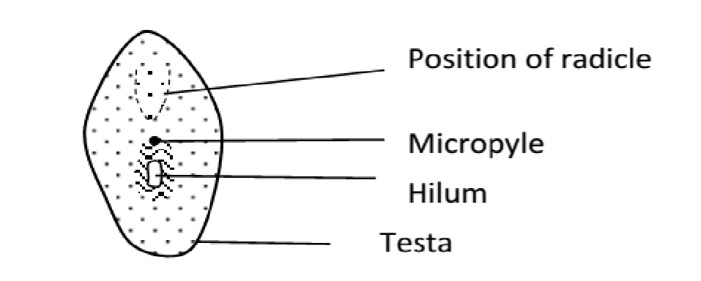

Internal structure of a dicot seed
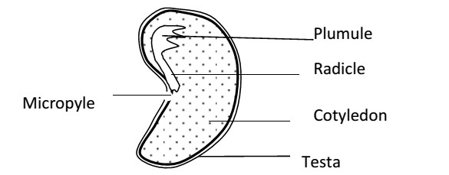
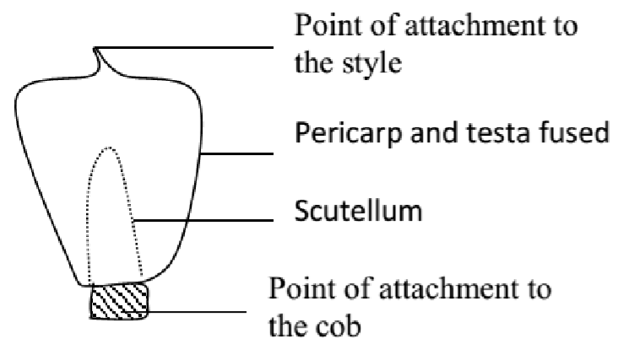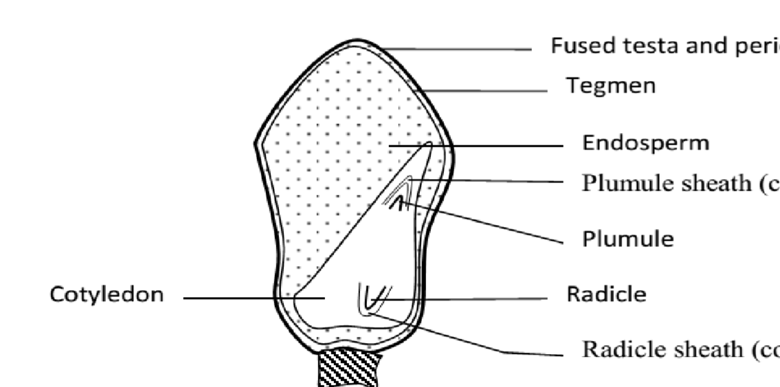
External structure of a monocot seed

i)

Testa

It is a protective
-
covering of the embryo of the seed formed from the integuments.
Internal structure of a maize
seed

It is usually hard and dry. It protects it from fungi, bacteria and insects.
- Tegmen
It is the inner membrane of the seed coat and it is also used for protection.
- Micropyle
It is a narrow opening into the seed through which water, mineral salts and oxygen enter during germination.
- Radicle
It is a seed root (embryo root) which develops into primary root of the plant. A developing root has a root cap which bores through the soil particles and protects the newly formed cells at the root tip from mechanical damage.
- Hilium
It’s a scar of attachment left by the stalk of the ovule to the ovary wall.
- Endosperm
Stores food especially starch for the embryo.
- Scutellum or cotyledon
Digests and absorbs food stored in the endosperm. It provides food to the whole seed.
- Coleorhiza
It is the radicle sheath that offers protection to the radicle.
- Coleoptile
It is the plumule sheath that offers protection to the plumule.
- Cotyledon
These contain stored food like starch, proteins and liquids for the initial growth of the embryo during germination.

